**Aerodynamic Analysis of NACA 2415 Airfoil Using XFLR5**

**1. Introduction**

The NACA 2415 is a four-digit airfoil with moderate camber and relatively high thickness, making it a popular choice for light aircraft and general aviation applications.  
Its designation describes its geometry:

* **Maximum Camber:** 2% of chord, located at **40.14%** of chord length
* **Maximum Thickness:** 15% of chord, located at **29.73%** of chord length

This geometry offers a balance between aerodynamic performance and structural strength, with enough internal volume for components like spars, control linkages, and in larger aircraft, fuel tanks or retractable landing gear.

For this study, **XFLR5 Direct Analysis** was conducted at three Reynolds numbers (**Re = 0.1M, 0.207M, and 0.5M**) with corresponding Mach numbers, Ncrit = 9, and a panel resolution of 199 to ensure smooth and accurate results.

**2. Results and Graph Analysis**

**2.1 Drag Polar: Cl vs Cd *(Top-left)***

* **Purpose:** Represents aerodynamic efficiency and viscous effects.
* **Axes:**
  + Horizontal — **Cd**: total drag coefficient (skin friction + pressure drag)
  + Vertical — **Cl**: lift coefficient
* **Interpretation:**
  + The curve initially rises, indicating increasing lift with increasing drag.
  + The “loop” marks stall behaviour — beyond the peak Cl, drag increases faster than lift due to large-scale separation.
  + At low Cd, the slope of the curve relates to the **lift-to-drag ratio (Cl/Cd)**, a key indicator of aerodynamic efficiency.
  + Higher Reynolds numbers show longer, smoother curves with higher Cl/Cd due to delayed boundary layer separation and reduced drag.

**Importance:** The drag polar helps identify efficient cruise conditions and stall margins, crucial for aircraft performance optimisation.

**2.2 Lift Curve: Cl vs α *(Top-middle)***

* **Purpose:** Shows lift curve slope and stall behaviour.
* **Axes:**
  + Horizontal — **α**: geometric angle of attack (degrees)
  + Vertical — **Cl**: lift coefficient
* **Interpretation:**
  + In the linear range, Cl increases almost proportionally with α, with slope slightly less than the theoretical **2π per radian** for thin airfoils due to thickness and viscous effects.
  + Stall occurs at α ≈ **12–15°**, after which Cl drops due to flow separation.
  + Higher Reynolds numbers result in slightly higher Cl,max and delayed stall.

**Importance:** Defines operational α ranges for take-off, climb, and maneuvering, and aids in predicting lift performance at various speeds.

**2.3 Pitching Moment Curve: Cm vs α *(Top-right)***

* **Purpose:** Assesses longitudinal stability and trim requirements.
* **Axes:**
  + Horizontal — **α**: angle of attack (degrees)
  + Vertical — **Cm**: pitching moment coefficient (about aerodynamic center ~25% chord)
* **Interpretation:**
  + Cm remains **negative** across most of the α range — a characteristic of cambered airfoils — indicating a nose-down pitching moment that enhances static longitudinal stability with conventional tails.
  + Near stall, Cm fluctuates due to separated flow altering pressure distribution.
  + A more negative Cm requires greater tail downforce to trim.

**Importance:** This curve is essential for sizing the tailplane and ensuring stable trim behaviour.

**2.4 Transition Location: Cl vs Cd with Xtr Top *(Bottom-left)***

* **Purpose:** Shows where the upper surface boundary layer transitions from laminar to turbulent flow.
* **Axes:**
  + Horizontal — **Cd**: total drag coefficient
  + Vertical — **Cl**: lift coefficient
* **Interpretation:**
  + At higher Re, transition occurs further downstream, extending laminar flow and reducing skin friction drag.
  + In the stall region, transition moves forward due to separation bubbles.
  + Longer laminar runs are beneficial for drag reduction in cruise.

**Importance:** Transition data helps refine surface finish and contour design to maximise laminar flow benefits.

**2.5 Hinge Force Coefficient: Fy vs α *(Bottom-right)***

* **Purpose:** Relates to control surface loads (e.g., flaps, ailerons).
* **Interpretation:**
  + In this analysis, the curve is zero since no control surfaces were modelled.
  + With control surfaces, this graph would show hinge forces versus α, vital for actuator sizing and pilot workload prediction.

**3. Aerodynamic Behaviour & Compatibility**

The NACA 2415 demonstrates **balanced aerodynamic behaviour**:

* **Lift Performance:** Good maximum lift capability, adequate for short take-off and landing operations.
* **Stability:** Negative Cm ensures predictable pitch stability with a conventional tail.
* **Efficiency:** High Cl/Cd at cruise α, especially at higher Re, makes it suitable for general aviation aircraft.
* **Structural Benefits:** 15% thickness offers strong internal structure capability.

**Limitations:** At very low Reynolds numbers (small UAVs, slow-speed gliders), earlier stall onset and reduced laminar run may impact performance compared to low-Re-optimised thin airfoils.

**4. Conclusion**

The XFLR5 analysis confirms that the NACA 2415 is a robust, versatile airfoil with predictable lift, drag, and stability characteristics. Its delayed stall and favourable cruise efficiency at moderate Reynolds numbers make it ideal for light aircraft, trainers, and general aviation applications. Its geometry provides a structural advantage, while its aerodynamic profile ensures safe and efficient performance.

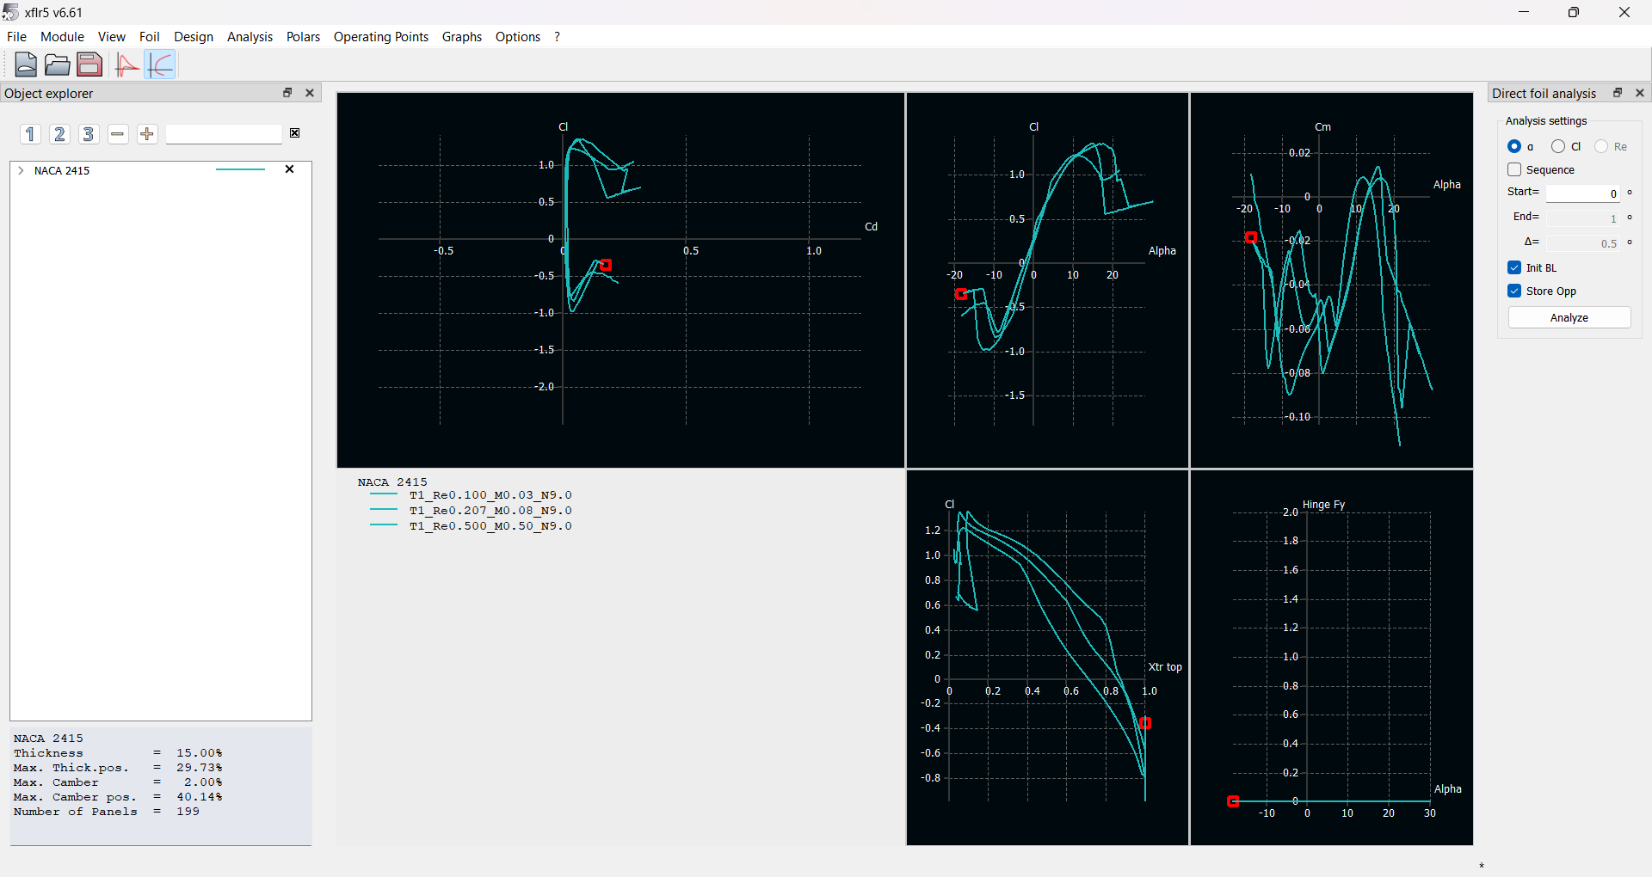

1. Top-left: ClC_l vs CdC_d (Lift Coefficient vs Drag Coefficient — Drag Polar) • Purpose: This plot is the drag polar, representing aerodynamic efficiency and viscous effects. • Horizontal axis: CdC_d — total drag coefficient (skin friction + pressure drag). • Vertical axis: ClC_l — lift coefficient. • Interpretation: o The curved “loop” indicates stall behavior: the initial upward trend shows increasing lift with increasing drag, up to a maximum ClC_l. o Beyond this, flow separation causes drag to increase faster than lift, leading to the downturn. o At low CdC_d, the slope of the curve is directly related to the lift-to-drag ratio (Cl/Cd)(C_l / C_d), a key indicator of aerodynamic efficiency. o The loops differ by Reynolds number — higher ReRe tends to have better L/DL/D ratios because the boundary layer stays attached longer, reducing drag. ________________________________________ 2. Top-middle: ClC_l vs α\alpha (Lift Curve — Angle of Attack) • Purpose: The lift curve slope and stall characteristics. • Horizontal axis: α\alpha (degrees) — geometric angle of attack. • Vertical axis: ClC_l — lift coefficient. • Interpretation: o In the linear region, ClC_l increases approximately linearly with α\alpha with slope a≈2πa \approx 2\pi per radian for thin airfoils, but here slightly lower due to thickness and viscous effects. o At around α≈12−15∘\alpha \approx 12-15^\circ, the curve peaks — indicating stall onset. o Post-stall, ClC_l drops due to large-scale separation. o The slope differences between curves are due to Reynolds number — higher ReRe → delayed stall and slightly higher Cl,maxC_{l,max}. ________________________________________ 3. Top-right: CmC_m vs α\alpha (Pitching Moment Curve) • Purpose: Longitudinal stability and trim characteristics. • Horizontal axis: α\alpha — angle of attack. • Vertical axis: CmC_m — pitching moment coefficient about the aerodynamic center (often near 25% chord). • Interpretation: o For cambered airfoils like NACA 2415, CmC_m is generally negative, indicating a nose-down pitching moment — stable for most aircraft tail configurations. o The curve fluctuates at high α\alpha due to separated flow altering the pressure distribution. o A more negative CmC_m means a higher tail downforce is required to trim the aircraft. ________________________________________ 4. Bottom-left: ClC_l vs CdC_d — Xtr Top (Laminar-to-turbulent transition location) • Purpose: Shows transition location on the upper surface relative to aerodynamic performance. • Horizontal axis: CdC_d. • Vertical axis: ClC_l. • Color markers (here as curves) correspond to the chordwise position where transition from laminar to turbulent boundary layer occurs on the upper surface (Xtr top). • Interpretation: o Higher Reynolds numbers → transition occurs further downstream, delaying turbulent drag rise. o Stall region shows early transition due to separation bubbles. o This is important for laminar-flow airfoils, where maintaining a long laminar run reduces skin friction drag. ________________________________________ 5. Bottom-right: Hinge FyF_y vs α\alpha (Hinge Moment Force in Y direction) • Purpose: This relates to control surface loads (like ailerons, flaps). • Horizontal axis: α\alpha. • Vertical axis: FyF_y — hinge force coefficient in the normal direction. • Interpretation: o For a plain airfoil without flaps, this remains zero (as here). o If flaps/ailerons were modeled, this would show control hinge forces versus angle of attack. ________________________________________ Extra Parameters from Bottom-left Text Box • Thickness = 15% chord — This is a relatively thick airfoil, beneficial for structural strength. • Max thickness position = 29.73% chord — Slightly forward of mid-chord, typical for NACA 4-digit. • Max camber = 2% chord, at 40.14% chord position — Moderate camber, giving a good compromise between lift and drag for moderate-speed aircraft. • Panels = 199 — Higher number ensures smoother pressure distribution calculation.